Weber County Planning Division

MEMORANDUM

To: Weber County Commission

From: Bill Cobabe, Planning
Date: June 13, 2023
Subject: Promontory Commerce Center Zoning Map Amendment

County Commissioners,

On May 16, 2023, the Staff prepared a staff report regarding a proposed ordinance which amends the Weber County Zoning Map. This ordinance would change certain property from the A-1 (Agricultural) zone to the M-T (Manufacturing and Technology) zone, allowing for various uses and regulations associated with this zone, and approving an accompanying development agreement. This staff report outlined the reasoning for changing the zone. This memo is to clarify certain points about the proposed zone change and development agreement. There have been no changes to the proposed zone change since the staff report and accompanying ordinance from the May 16, 2023 report, except with regard to the development agreement, which changes are outlined in the attached.
Staff is generally comfortable with the proposed alterations to the changes noted. However, the County Commission should be aware that the developer is proposing the elimination of the 300’ setback from the Weber River, which flows next to the property. Section 108-7-23 River And Stream Corridor Setbacks - Western Weber County, subsection (a) notes:

No structure, accessory structure, road, or parking area shall be built within the required setback from a river or stream as measured from the high water mark of the river or stream. The high water mark shall be determined by the county engineer. The areas within the setback shall be maintained in a manner that protects the quality of water in the river or stream and the habitat of native vegetation and wildlife along the river or stream.
- Structures, accessory structures, roads, or parking areas shall not be developed or located within 300 feet on both sides of the Weber River from the high water mark of the river.
Due to the nature of this development, Staff had originally proposed that the setback be modified for an average setback of 300’ from the Weber River, allowing for some building development up to the 100’ required river protection area, per the Development Agreement. However, the Code section referenced in the Development Agreement and cited above has been modified (as of April 2022) and now requires a 300’ setback. This flexibility (the average setback) was a concession to the Developer in the previous iteration of the Development Agreement. The modified Development Agreement would eliminate this requirement altogether and only have a 100’ river protection setback. Because this may or may not be the desire of the County Commission, Staff felt it important enough to single out for your information and attention.

The attached Development Agreement reflects these changes as proposed by the Developer.

ATTACHMENTS
Attachment A – Email from the Black Pine Group
Attachment B – Highlighted Changes to the Development Agreement

(Complete Development Agreement attached separately)

Attachment A – Email from Black Pine Group
From: Daniel Stephens <daniel@theblackpinegroup.com>
Sent: Wednesday, June 7, 2023 3:37 PM
To: Cobabe,Bill <bcobabe@webercountyutah.gov>; Dallin Curriden <Dallin@theblackpinegroup.com>; Amanda Anderson <amanda@theblackpinegroup.com>; Jake Earl <jake@theblackpinegroup.com>; Ewert,Charles <cewert@webercountyutah.gov>; Russell,Stephanie <srussell@webercountyutah.gov>;
Cc: cjenson@swlaw.com; Myers,Gary <gmyers@webercountyutah.gov>; Grover,Rick <rgrover@webercountyutah.gov>; Wilkinson, Sean <swilkinson@webercountyutah.gov>; Keogh,Liam <lkeogh@webercountyutah.gov>
Subject: [EXTERNAL] RE: Promontory Commerce Center - Recurring

All,

As discussed with a few of you previously, given recent developments in the PID/TIF discussions we were advised to look through the development agreement to identify a few areas that we may be able to increase square footage or decrease costs which would help to make this project financially feasible. We’ve identified two potential options that are county related we’d like to readdress in the development agreement.

- Ring Road - You’ll see in the attached document we request one tweak which is to have the option to make this road either public or private. If we elect it to be public the language previously agreed upon is triggered, if we elect private then it no longer applies. This change could potentially unlock square footage by decreasing the ROW width allowing the buildings to grow and also have cost savings due to less materials.
- Removal of the 300’ average setback measured on a project wide basis. Along the same theme as the ring road this has the potential to allow square footage to grow which will help us absorb more costs and make the project more financially feasible. One other complication we hadn’t contemplated about this is the scenario where we sell a parcel and the new owner builds right on the 100’ setback line requiring the next parcel to overcompensate the setback in order for the average to be met. It will be hard to monitor and enforce unless we maintain ownership of every single parcel and build all the buildings.

I know these feel like last minute changes to a document that has been effectively done for some time but circumstances on the PID/TIF are changing in real time so we appreciate your willingness to work with us to make this project happen.

On the ‘upsizing’ issue below, we think the county is already protected from the risk identified. Craig’s interpretation: Section 6.5 is mutually beneficial in that it covers the parties’ obligations with respect to upsizing, and adds helpful clarification and optionality to the exaction standards in Utah law, so that the appropriate entity is allowed to request upsizing and developer or the project is not inappropriately put in a place to unfairly bear the cost of the upsizing.

Call me if you have any questions.

Thanks,

Daniel A. Stephens
Managing Partner
p: 801.675.8809 | m: 801.875.1480
daniel@theblackpinegroup.com

Attachment B – Highlighted Changes to the Development Agreement
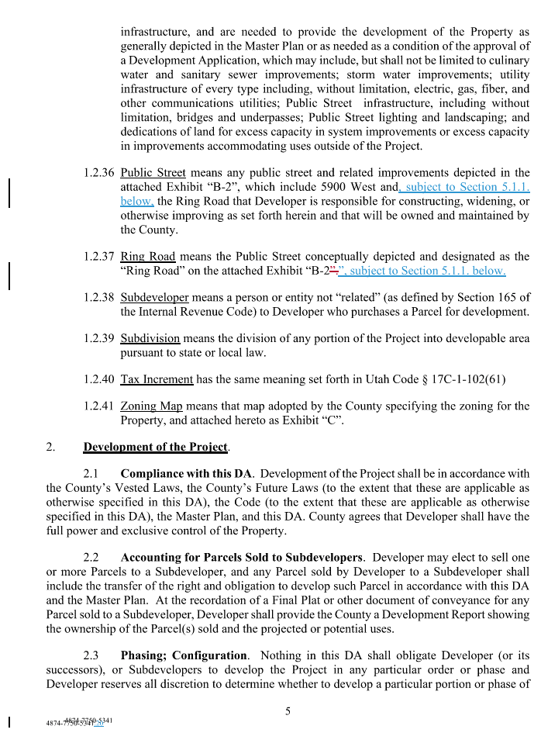
(changes from the previous iteration are in blue/red).
